

**Labar Arkira Asar Imi**

# **Via ashiliri! Ku ga nda aga dabari munagu! Ku ga hankal! Ku ga surpur kirung!**

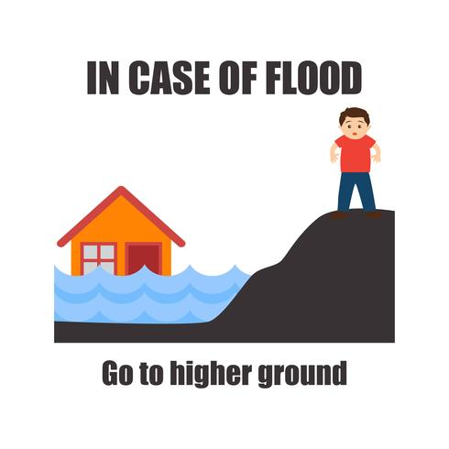

|  |  |
| --- | --- |
| IN CASE OF FLOOD Go to higher ground | GADIBAR ASAR IMI mai adar gar |

1. **Ku ngusha nda mbwa ma imi ivir tidu!**
2. **Suka ku ngusha ngwara ivi di imi ivir pida di mai!**
3. **Ga nda ga ciba odikura yal ginyi!**
4. **Ku ga nda cipcu kuga surpur kirung ara shilgu kasuwa!**
5. **Suka ga sa imi kuku ivir wi hiu thlal mai. A cittu iri kiranga!**
6. **Ga hankal aga bu ginyi! Imir thlal ivir shili aga mukufu kuku aga balmi!**
7. **Suka ga cadu su lang lang akwa imir didii mai! Nanda cittu na dumi!**
8. **Ku ga nda pudum ara mya kiliri imi! ku ga nger vul imi kuku ivir wi ko thlal!**
9. **Ku ga ɗu maja nurung.**
10. **Ku ga shashili ki ma lapia ga thlia kir!**